
5th SEECCM2023 ECCOMAS Conference
July 5-7, 2023, Vrnjačka Banja, Serbia

paper title (Times New Roman, 12 pt., bold)

First A. Author¹, Second B. Author², Third C. Author² (authors, 11 pt., bold)

¹ Institute of Mechanics (Times New Roman, 11pt.)
Ruhr-Universitat Bochum, Universitatsstr. 150, D-44801 Bochum, Germany
e-mail: first@first.com
² Faculty of Mechanical Engineering,
The University of Belgrade, Kraljice Marije 16, 11120 Belgrade 35
e-mail: second@second.com , third@third.com

Abstract (150 - 450 words):

Format of paper should be Word document. The paper has to be written in English using single spacing and Times-Roman font with 11 pt size.

Key words: word, word…(Times New Roman, 11pt.)

1. Introduction (section title, 11 pt, bold)

(Times New Roman, 11pt.) Following a long standing tradition of ECCOMAS Conferences You are invited to submit your abstract to one of the following conference topics: Solid Mechanics, Fluid Mechanics, Coupled Problems, Discrete Modeling, Multiscale Modeling, Biomechanics, Nanomedicine, Cardiovascular Mechanics, Tissue Engineering, Dental Mechanics, Bone Mechanics, Musculoskeletal Mechanics, Sport Biomechanics, Cellular and Molecular Mechanics, Medical Image Computing and Computational Chemistry. We would like to invite you to participate in the 5th SEECCM2023 ECCOMAS Conference in Vrnjačka Banja, Serbia.
By bringing together the experts and young researchers we aim to promote exchange of ideas in topics of mutual interests, to establish links between scientific communities with complementary activities and to encourage them for collaboration in times to come.

2. Instructions…

(Times New Roman, 11pt.) Full paper (number of pages, with figures and tables within the text, must be: 6, 8 or 10). Literature or references are cited in the text by number in angular parantheses, e.g. [1].

2.1 Instructions… (subsection title, 11 pt, italic)

(Times New Roman, 11pt.) Equations are to be prepared with Word’s Equation Editor or by MathType. Parameters for equation typing are the size 11 pt TNR; subscripts and superscripts 9 pt, sub-subscripts are 7 pt. Numbers, parantheses and capital Greek symbols are not italic. All latin type variables A, B, X, Y, a, b, x, y as well as small Greek symbols are italic. For example: Sanford [13] generalizes the previous solution by considering a complex function
$η\left(z\right)=z⋅φ^{''}\left(z\right)+ψ^{'}\left(z\right)$, (1)
Graphs/Illustrations/Tables should be placed on the appropriate page, with the corresponding consecutively number and explanations under them (10 pt). The Figure 1 shows…
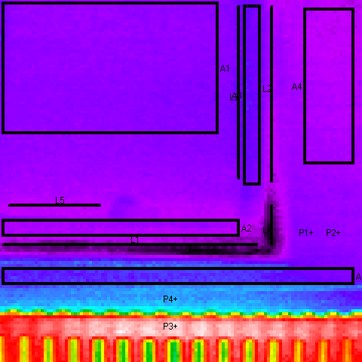
Fig. 1. Picture…

Figures and tables are centered … The text in Tables is TNR 10 pt, and is centered in table columns. See example below. It is shown in Table 1 that…

Results | Case 1 | Case 1 | Case 1 | Case 1
R1 | 3 | 1.2 | 4 | 5.9
R2 | 2.3 | 2.3 | 8 | 7.9

Table 1. Example

Please keep yourself to this template in preparing your paper, some deviations from proposed form are acceptable and will be corrected by the editors.
Looking forward to meet you in Vrnjačka Banja. More information will be available at http://www.seeccm2023.kg.ac.rs/.

3. Conclusions

(Times New Roman, 11pt.) The paper will be available both in paper (proceedings) and in digital form. Please, also give these information to other participants you know. Thanks for your contribution. The Organizing Committee.

References

- Lancaster P., Free vibrations of lightly damped systems by perturbation methods, Quarterly Journal of Mechanics and Applied Mathematics, Vol. 13, 138-155, 1960.
- Brandon, J.,A., Strategies for Structural Dynamic Modification, John Wiley & Sons INC, New York, 1990.

